**WEEK 12 ASSIGNMENT BDWUP**

**USE MERGE JOIN TO JOIN TWO DIFFERENT DATABASE ROWS**

**Aim:**

To connect data from a excel file and click preview rows to verify the file is being read correctly.

**Algorithm:**

1.Start the process.

2.Create a Sales database using Excel.

3.Save the file in .xls format.

4.Open Pentaho Spoon tool for data integration.

5.Choose text input and text output for data retrieval.

6.Save the file.

7.Stop the process.

**OUTPUT:**

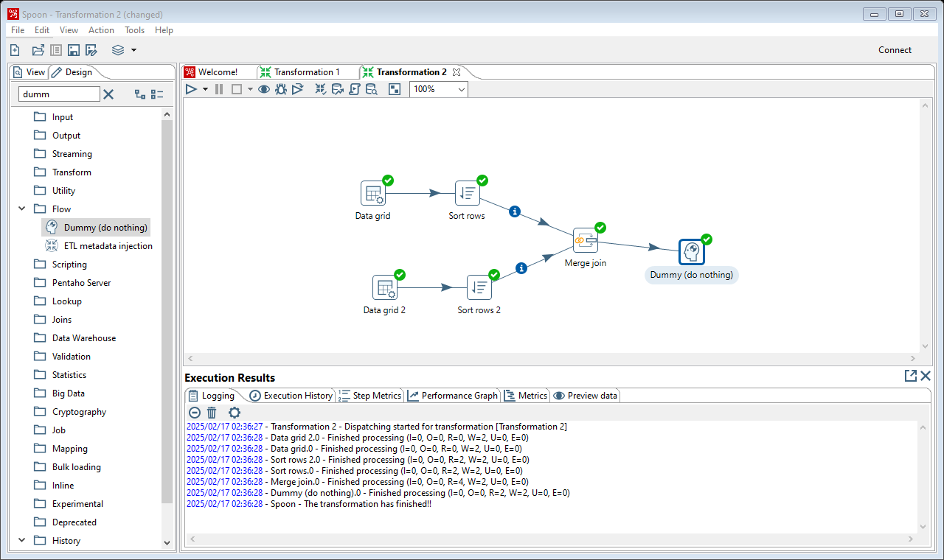

**Result :**

The above termination is executed successfully.